Hands-on Exercise No. 3
DigiSkills 3.0 Batch-02
Data Analytics & Business Intelligence

Ensure two tables exist
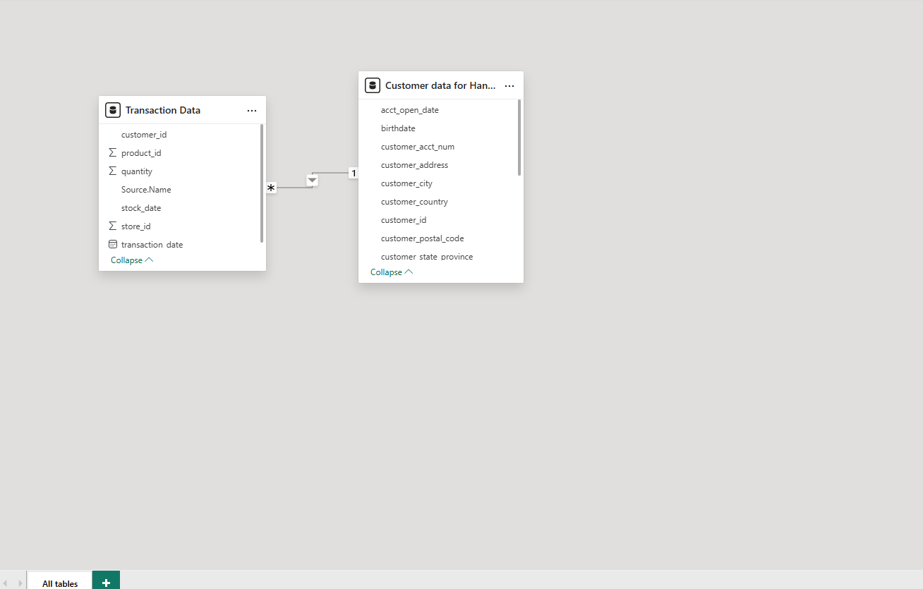

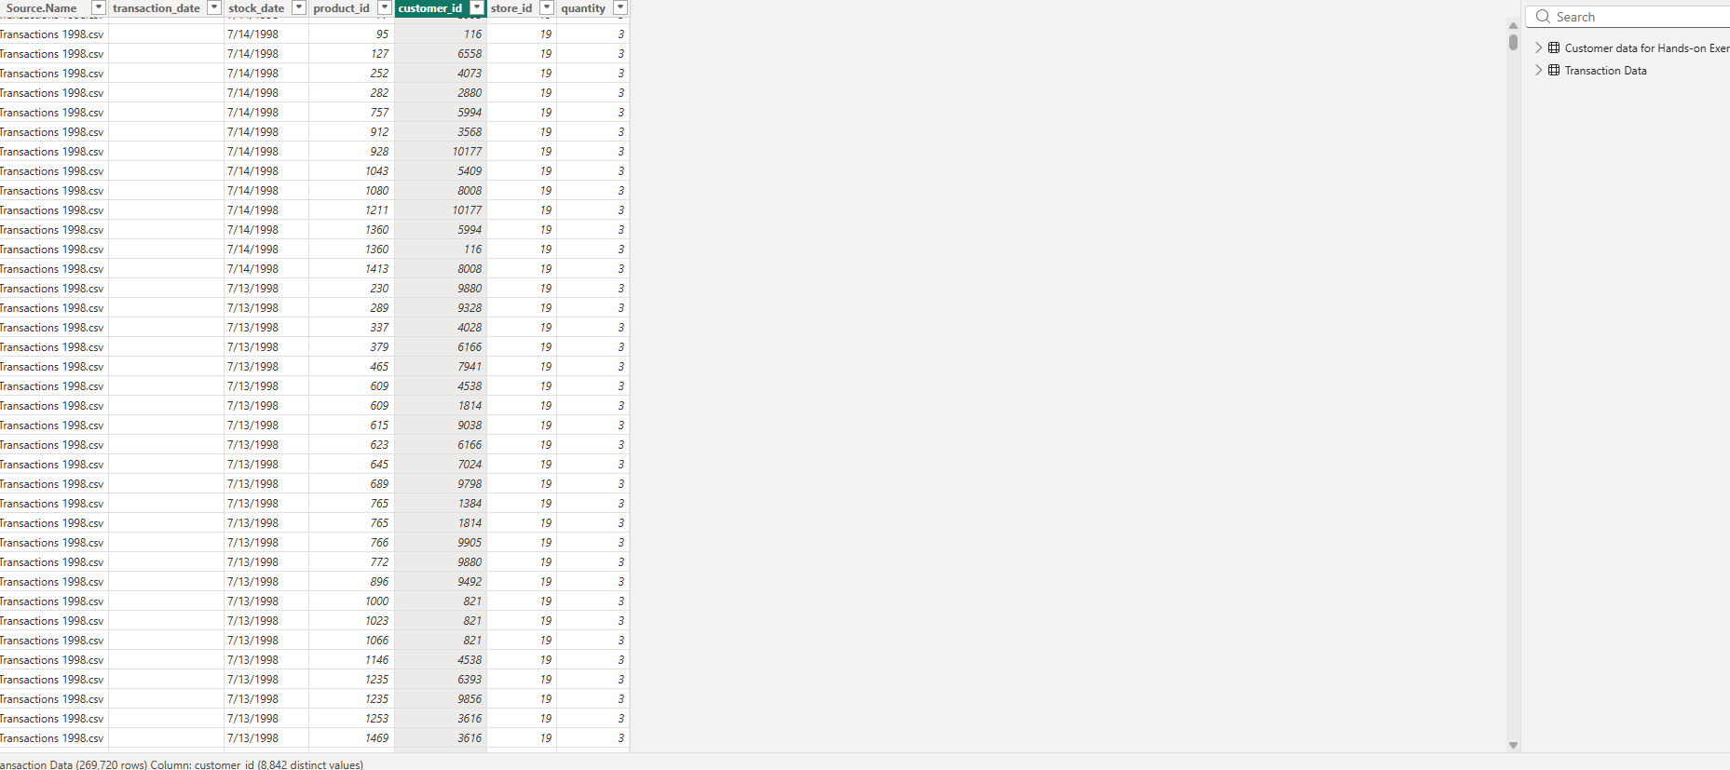
Goto Model View and delete the relationship which has been created automatically.
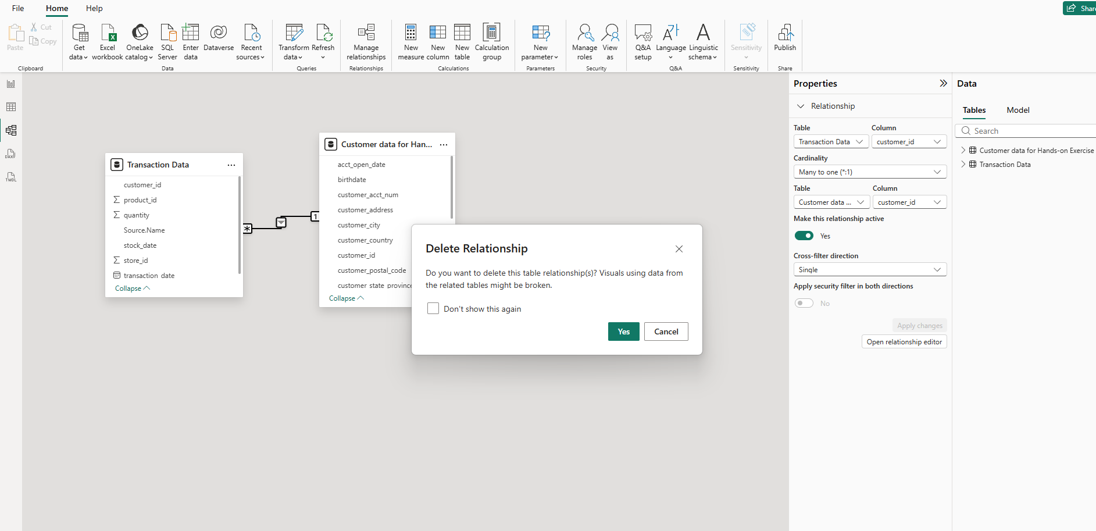

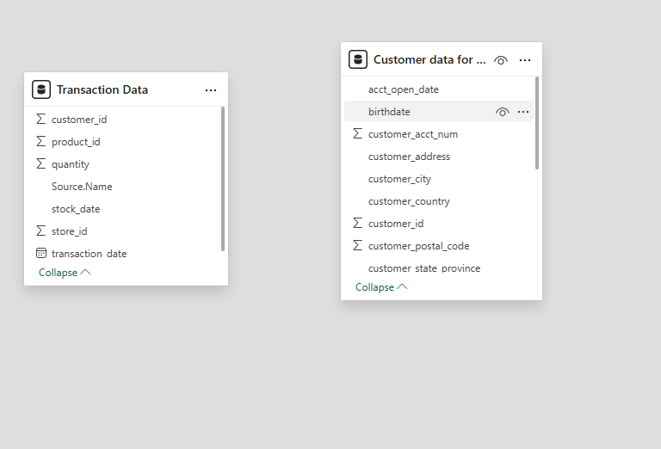

Recreate Relationships of Customer_Id from Customer_Lookup with Customer_Id in
Transaction Data
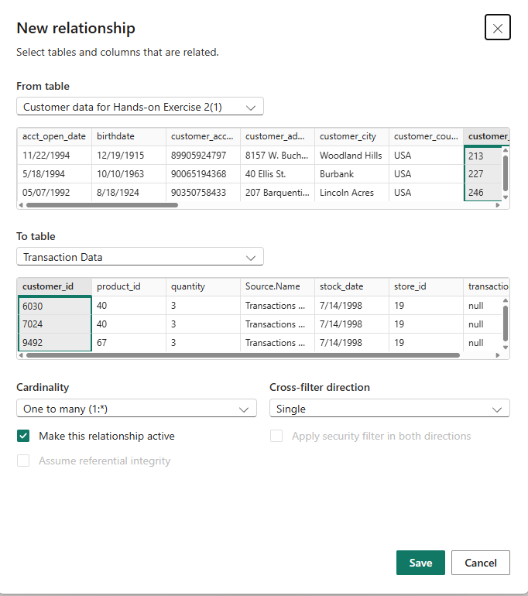

In Customer_Lookup, create calculated columns:
Customer Priority (Homeowner = Y & Card = Golden → Priority, else Standard)
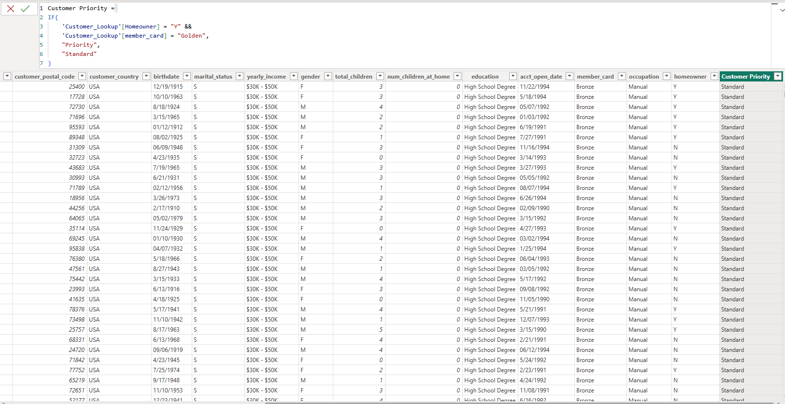

Current Age (using Birthdate)
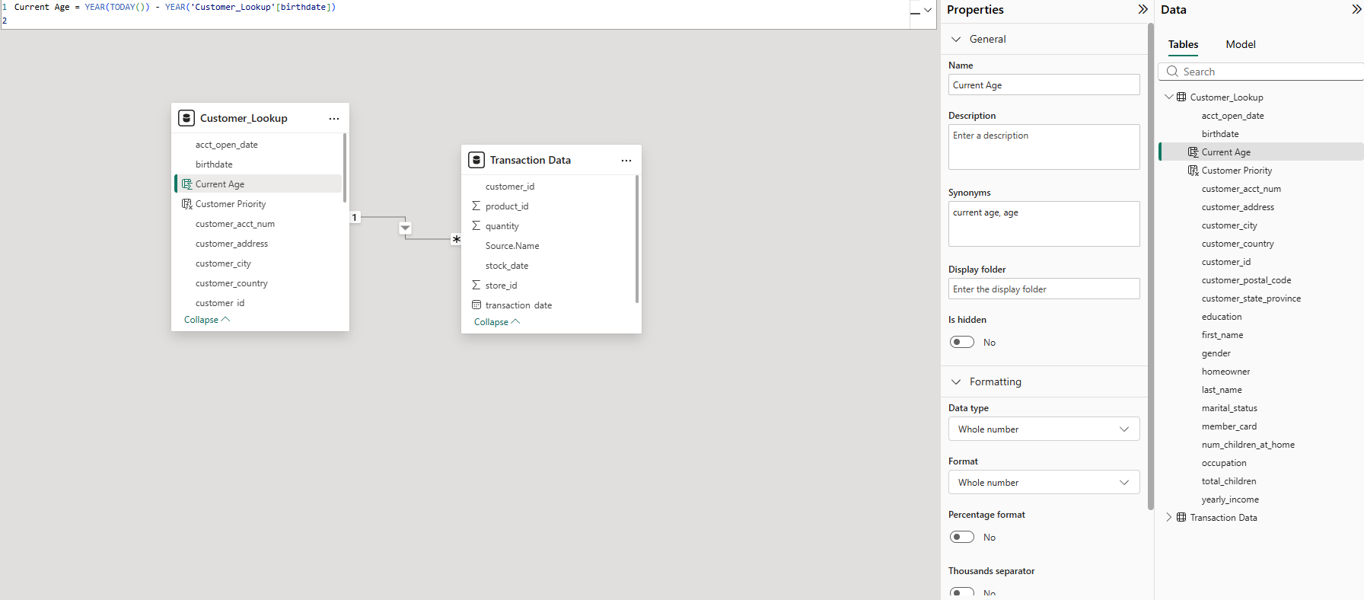

In Transaction Data, create measures:
Qty Sold (Sum of Quantity)?
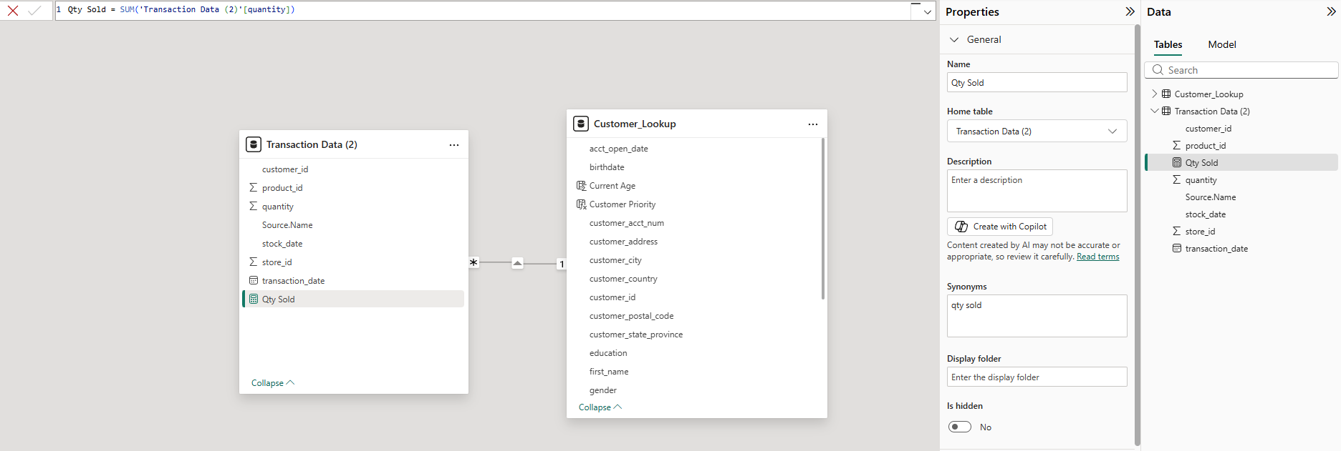

Total Orders (Count of Orders)
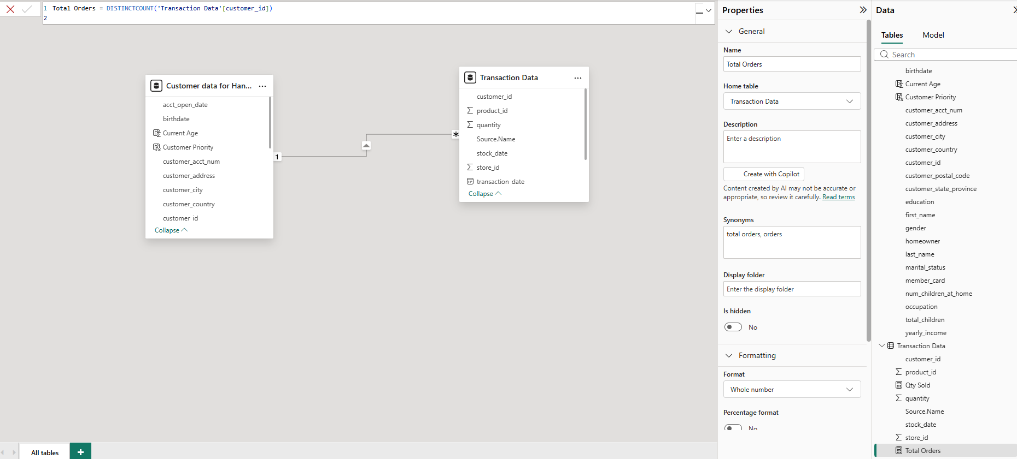

Bulk Orders (Orders with Quantity > 4)?
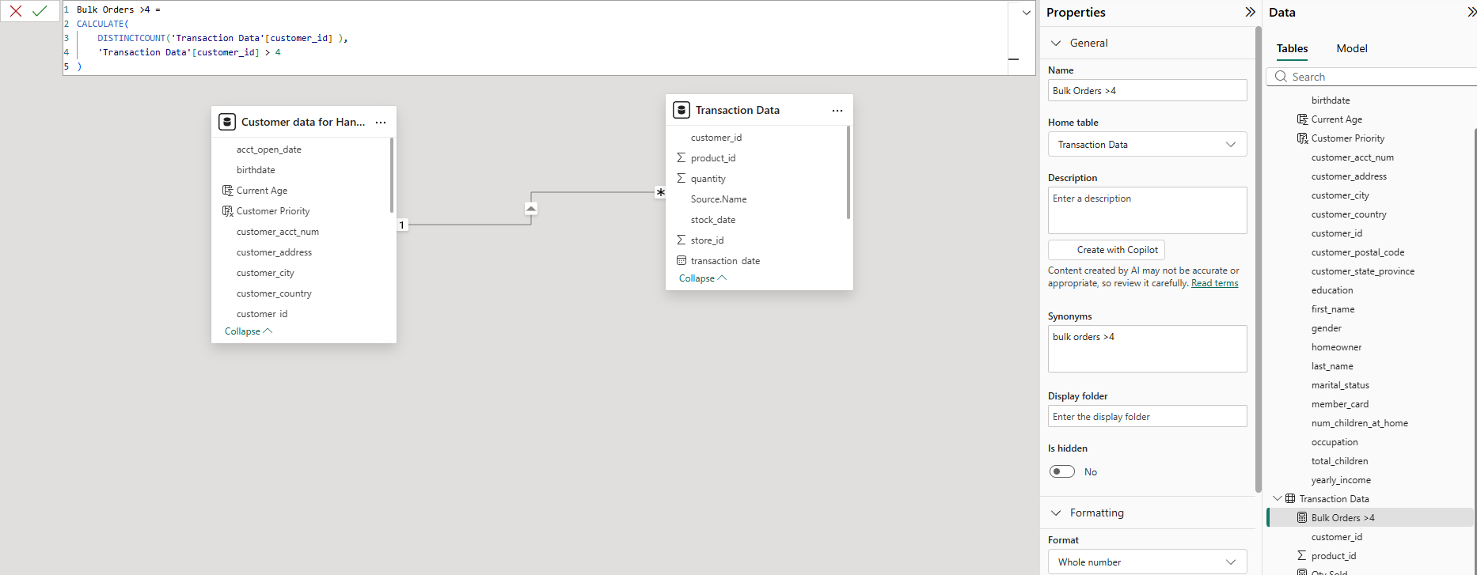

Validate results using a Matrix visual
